POLARIS MIGRATION

STAFF CLIENT ACCESS

Download the CCS_RemoteApp.wcx file and open the file.

When the connection screen opens, click Next to proceed.

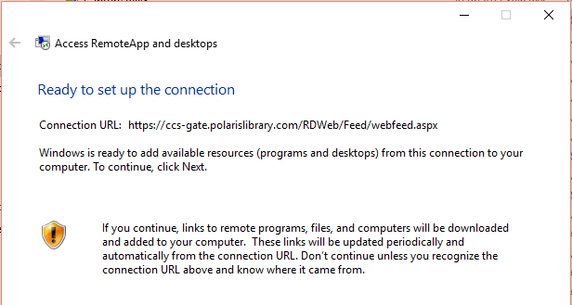

When asked to enter your credentials, log in with one of your library’s terminal server accounts, prefaced by the CCS domain. Check the box to remember credentials if desired, and then click OK.

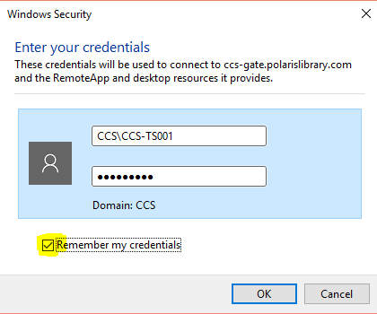

If your login is successful, you’ll see the screen below. Click Finish.
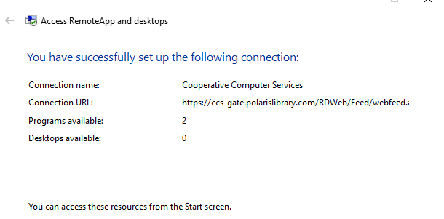
Access your computer’s control panel and select Remote App and Desktop Connections. When you connect, you’ll see the following:
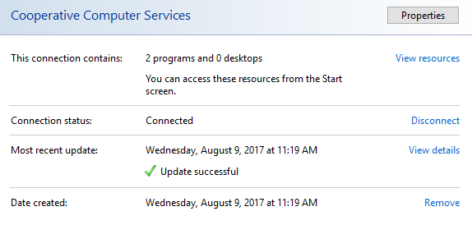
Click on View Resources. This will show you an icon labeled “Polaris ILS – Training (Cooperative Computer Services). Right click this icon, and send to desktop.
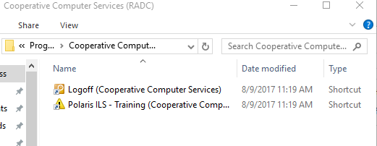

Once the icons are saved to your desktop, double click the “Polaris ILS” icon. The application will say “starting,” and then you’ll see a box similar to this. Check the highlighted box and select Yes.
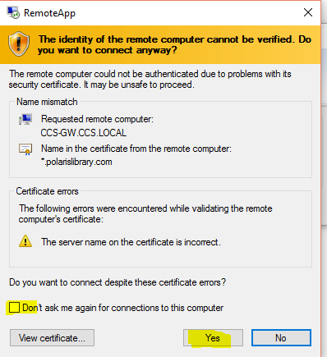

When selecting Yes, you’ll see a window notifying you that your computer is connecting to the remote app.
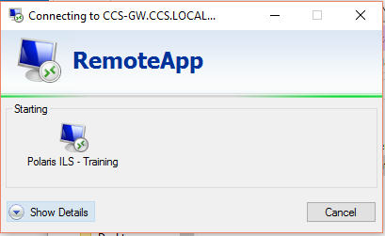
A profile is created for you the first time you connect to the Remote App, so this step may take a minute or two. Each time after this, when you login, it’ll go much quicker.
When you are successfully logged in, you’ll see a message box indicating what database you are connecting to (Training or Production) for the login for the Polaris client.

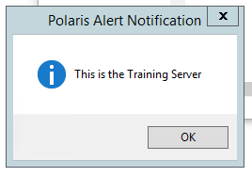

Click OK, and then you’ll be presented with the login for the Polaris client. Staff will log in to the Polaris client with their individual staff user name and password.

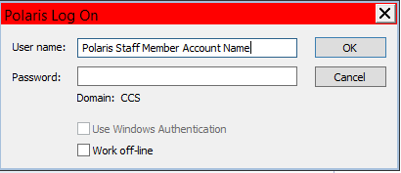

Note: After you have successfully installed the Remote Desktop app, locate the RDP files and compy them to the public desktop folder if that computer is used by more than one person. This will ensure Polaris is available for all users logging into this computer

